DAY 10 AI/ML CAPSTONE UPDATE DOCUMENT
Smart Expense Categorization

1. Project Objective
This Day 10 prototype moves Smart Expense Categorization from concept to a working AI/ML service. A user provides a natural-language expense description; the system predicts a category, calculates confidence, and returns the result through a Flask REST API.

2. Selected AI Feature
Primary feature: Smart Expense Categorization
Example: "I bought groceries for dinner" → "Food & Groceries" with a confidence score.

3. End-to-End Workflow
- User enters an expense description.
- Website, web application, mobile application, or API client sends it to the Flask REST API.
- Flask validates JSON, data type, empty input, and maximum length.
- TF-IDF converts text into numerical features.
- Logistic Regression predicts the most likely category.
- Model probabilities are used to calculate confidence.
- If confidence is below 0.45, the API returns Uncategorized and recommends manual selection.
- The API returns description, category, and confidence as JSON.

4. Technical Architecture
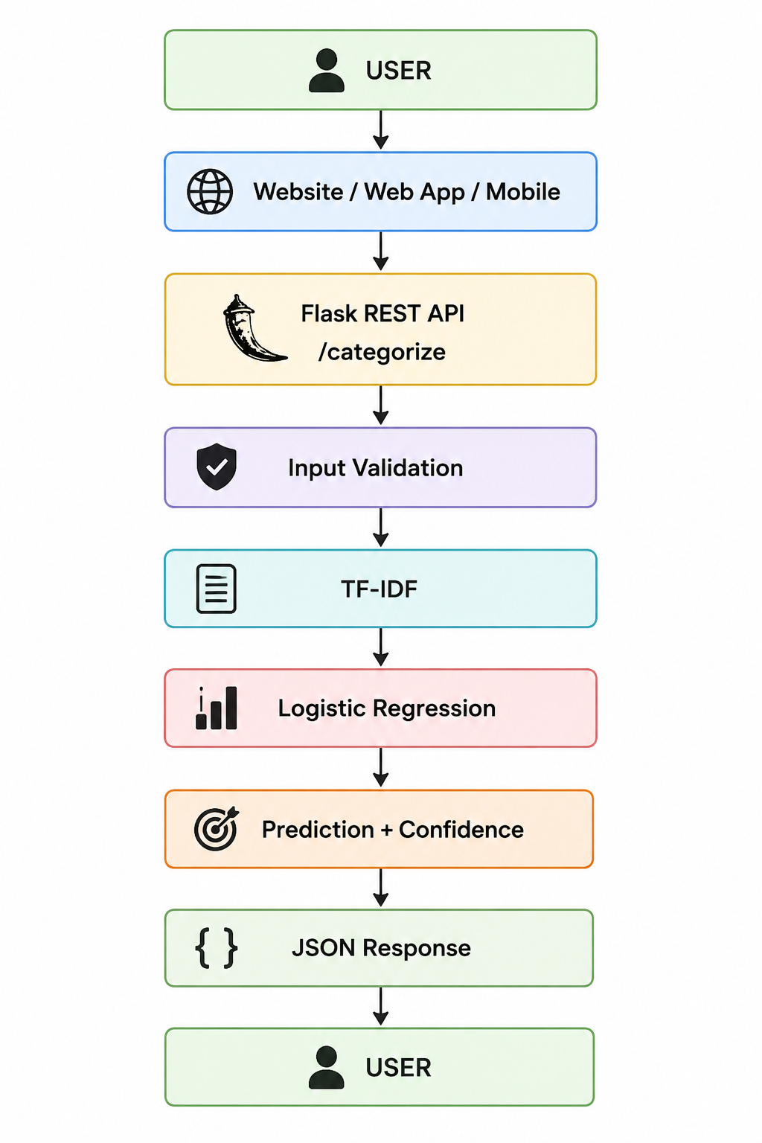

5. Input and Output
Input: natural-language expense description.
Example: {"expense": "I bought groceries for dinner"}
Output: {"description": "I bought groceries for dinner", "category": "Food & Groceries", "confidence": 0.XX}

6. Technology Stack
Component | Technology | Purpose
Programming | Python | Implementation
Feature extraction | TF-IDF | Convert text to numerical features
ML model | Logistic Regression | Multiclass expense classification
API | Flask REST API | Expose model to client applications
Testing | Thunder Client | Test requests, responses, and validation
Model persistence | Joblib | Save/load trained model and vectorizer

7. Dataset and Data Preparation
The prototype uses a labeled 500-record CSV dataset with expense descriptions and categories.
- expense – natural-language expense description
- category – target expense category
The data is split into 80% training and 20% testing using a stratified split.

8. Baseline and Evaluation
A majority-class baseline is calculated by always predicting the most frequent training category. The Logistic Regression model is evaluated against this baseline.
- Accuracy
- Precision (weighted)
- Recall (weighted)
- F1 Score (weighted)
- Confusion Matrix
Actual metric values should be copied from the latest train_model.py execution rather than guessed.
Metric | Latest Run
Baseline Accuracy | ________
Accuracy | ________
Precision | ________
Recall | ________
F1 Score | ________

9. API Specification
Endpoint: POST /categorize
Local URL: http://127.0.0.1:5000/categorize
Request: {"expense": "I bought groceries for dinner"}
Response: {"description": "I bought groceries for dinner", "category": "Food & Groceries", "confidence": 0.XX}

10. Validation and Error Handling
- JSON request is required.
- Expense field is required.
- Expense must be a string.
- Empty/whitespace-only descriptions are rejected.
- Descriptions over 200 characters are rejected.
- Confidence below 0.45 is handled as Uncategorized for manual review.

11. API Testing
Thunder Client is used to test successful predictions and invalid inputs.
Test | Sample Input | Expected Result
Food | I bought groceries for dinner | Food & Groceries + confidence
Transport | I paid for petrol | Transport + confidence
Shopping | I bought new shoes | Shopping + confidence
Bills | I paid my electricity bill | Bills + confidence
Education | I paid my university course fee | Education + confidence
Health | I bought medicine from the pharmacy | Health + confidence
Empty | expense = empty string | 400 Bad Request
Invalid type | expense = 12345 | 400 Bad Request
Missing field | {} | 400 Bad Request
Long input | >200 characters | 400 Bad Request

12. Website, Web App and Mobile Integration
Website: Send POST /categorize when the user enters an expense and display the suggested category and confidence.
Web Application: Call the same REST API during expense creation and store the accepted category with the transaction.
Mobile Application: Send the expense description to the REST API and show the predicted category in the expense-entry screen.

13. Security and Privacy
- Use HTTPS in production.
- Implement authentication and authorization.
- Store secrets in environment variables.
- Keep input validation and rate limiting.
- Avoid exposing sensitive financial information in logs.
- Send only necessary financial information to external services.
- Use appropriate database access controls.

14. Implementation Roadmap
- Completed: dataset preparation, train/test split, baseline, TF-IDF, Logistic Regression, evaluation, confusion matrix, saved model, Flask API, confidence score, validation, and Thunder Client testing.
- Next: larger dataset, model comparison, hyperparameter tuning, automated API tests, and database integration.
- Production: authentication, HTTPS, deployment, monitoring, website and mobile integration.
- Future: OCR receipts, voice expense entry, multilingual/Roman Urdu support, personalized categorization, and financial insights.

15. Project Files
- app.py – Flask REST API
- train_model.py – training and evaluation
- expense_category_dataset_500.csv – labeled dataset
- expense_model.pkl – trained model
- tfidf_vectorizer.pkl – fitted vectorizer
- model_evaluation.png – confusion matrix
- README.md – project documentation
- sample_inputs_outputs.md – API examples
- architecture_day10.png – architecture diagram
- screenshots/ – API testing evidence

16. Working POC Status
Status: Working prototype. The trained ML model is exposed through a Flask REST API and can be tested locally with Thunder Client. Additional security, scalability, monitoring, and deployment work is required before production use.

17. Submission Checklist
☐ Working AI/ML POC
☐ Source code
☐ 500-record dataset
☐ Saved trained model
☐ Saved TF-IDF vectorizer
☐ Model evaluation and confusion matrix
☐ Sample inputs/outputs
☐ API testing screenshots
☐ Architecture/update document
☐ README documentation
☐ Requirements file
☐ GitHub repository

18. Conclusion
The Day 10 implementation converts Smart Expense Categorization into a working AI/ML POC using TF-IDF, Logistic Regression, confidence handling, validation, evaluation, and a Flask REST API. The documented architecture and integration plan provide a clear path toward HisabDo website, web application, and mobile application integration.

